Change Order Request

June 23, 2015

Chinn Construction, LLC
14715 NE 95th Street, Suite 101
Redmond, WA 98052
Attn: Charlie Poggemann

Re: Hadley Apartment Project – Change Order Request

Charlie,

ASI-03 relocated the elevator machine room after the L2 deck slab had already been placed. The hub drain for the elevator machine room AC unit will need to be moved to the new location, which will require structural imaging and core drilling. Also, per onsite conversations, no plumbing is allowed to be in this room and will need to be relocated. Total cost for structural imaging, core drilling, filling un-used core holes, and costs for updating drawings is $1,150 + 10% OH&P = $1,265. Please let me know if you have any questions or comments. Thank you.

Sincerely,
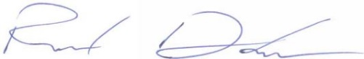
Richard Donelson
Project Manager / Estimator
LEED® Green Associate
richd@owpllc.net
425-591-4296 cell

